**OUTPUT SCREENSHOTS:**

**GREEDY ALGORITHM:**

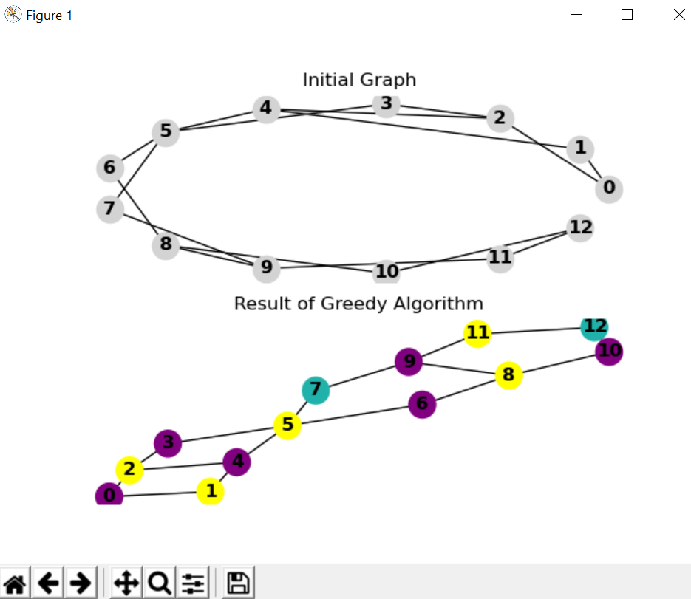

**Time elapsed:**

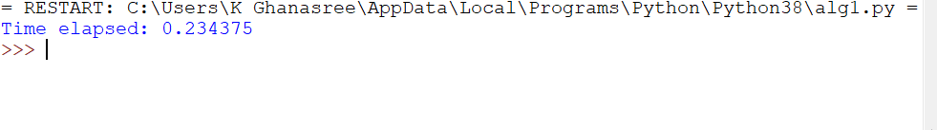

**BACK TRACKING ALGORITHM:**

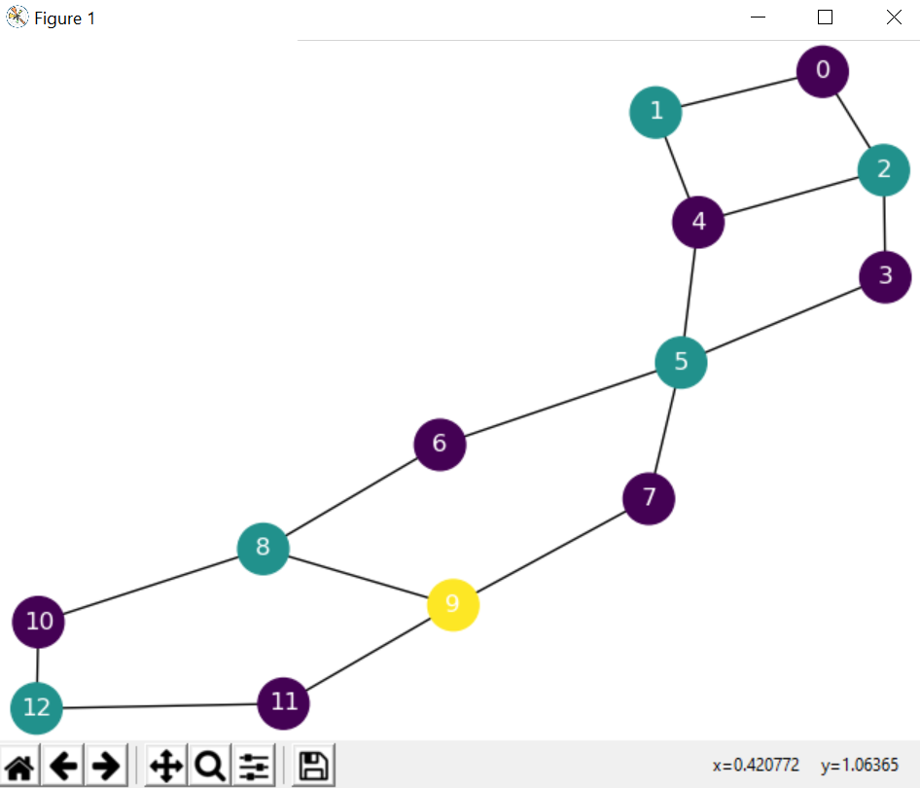

**Time elapsed:**

